NAME___________________________LAB MEETING DAY/TIME________________

Lab 2: GEOLOGIC TIME

**For Lab 2, we will be completing Exercises 1 and 2 in your lab manual.** You will record your answers on this document. Be sure to read ALL text of the lab as you work through the exercise – there is valuable information in the readings that will help you complete the exercises. **BELOW, WRITE YOUR ANSWERS AS DIRECTED IN THE LAB MANUAL.**

# **Exercise 1, PART A**

**Label the sequences of events on the figures below and on next page**

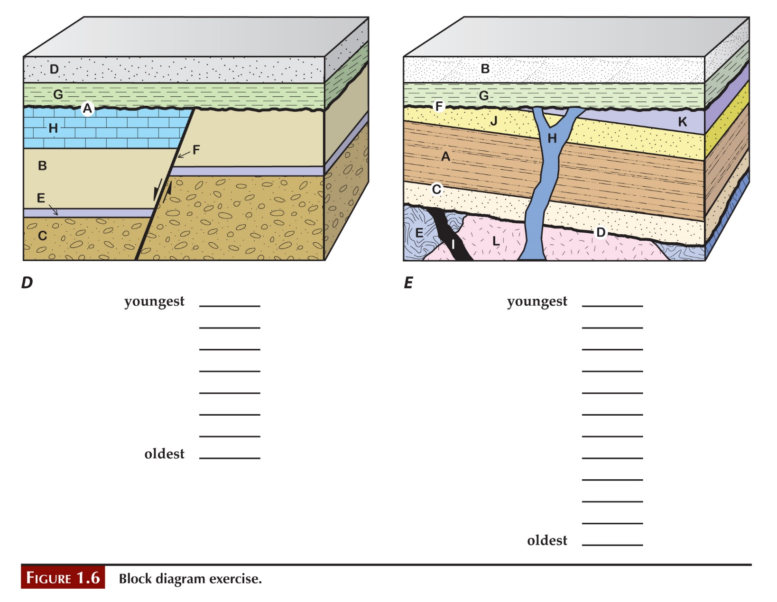

# **Exercise 1, PArt B**

**1.**

**2.**

**3.**

**4.**

**5.**

**6.**

**7.**

**8.**

**9.**

**10.**

**11.**

**12.**

**13.**

**14.**

# **Exercise 1 - Part C**

**1. Make a list here that puts events in order, oldest to youngest.**

**2.**

**3.**

**4.**

**5.**

**3.30**

# **Go on to exercise 2 in your lab manual**

# **Exercise 2 – Conodont data**

**1. Follow the directions on page 21 to complete the figure below.** 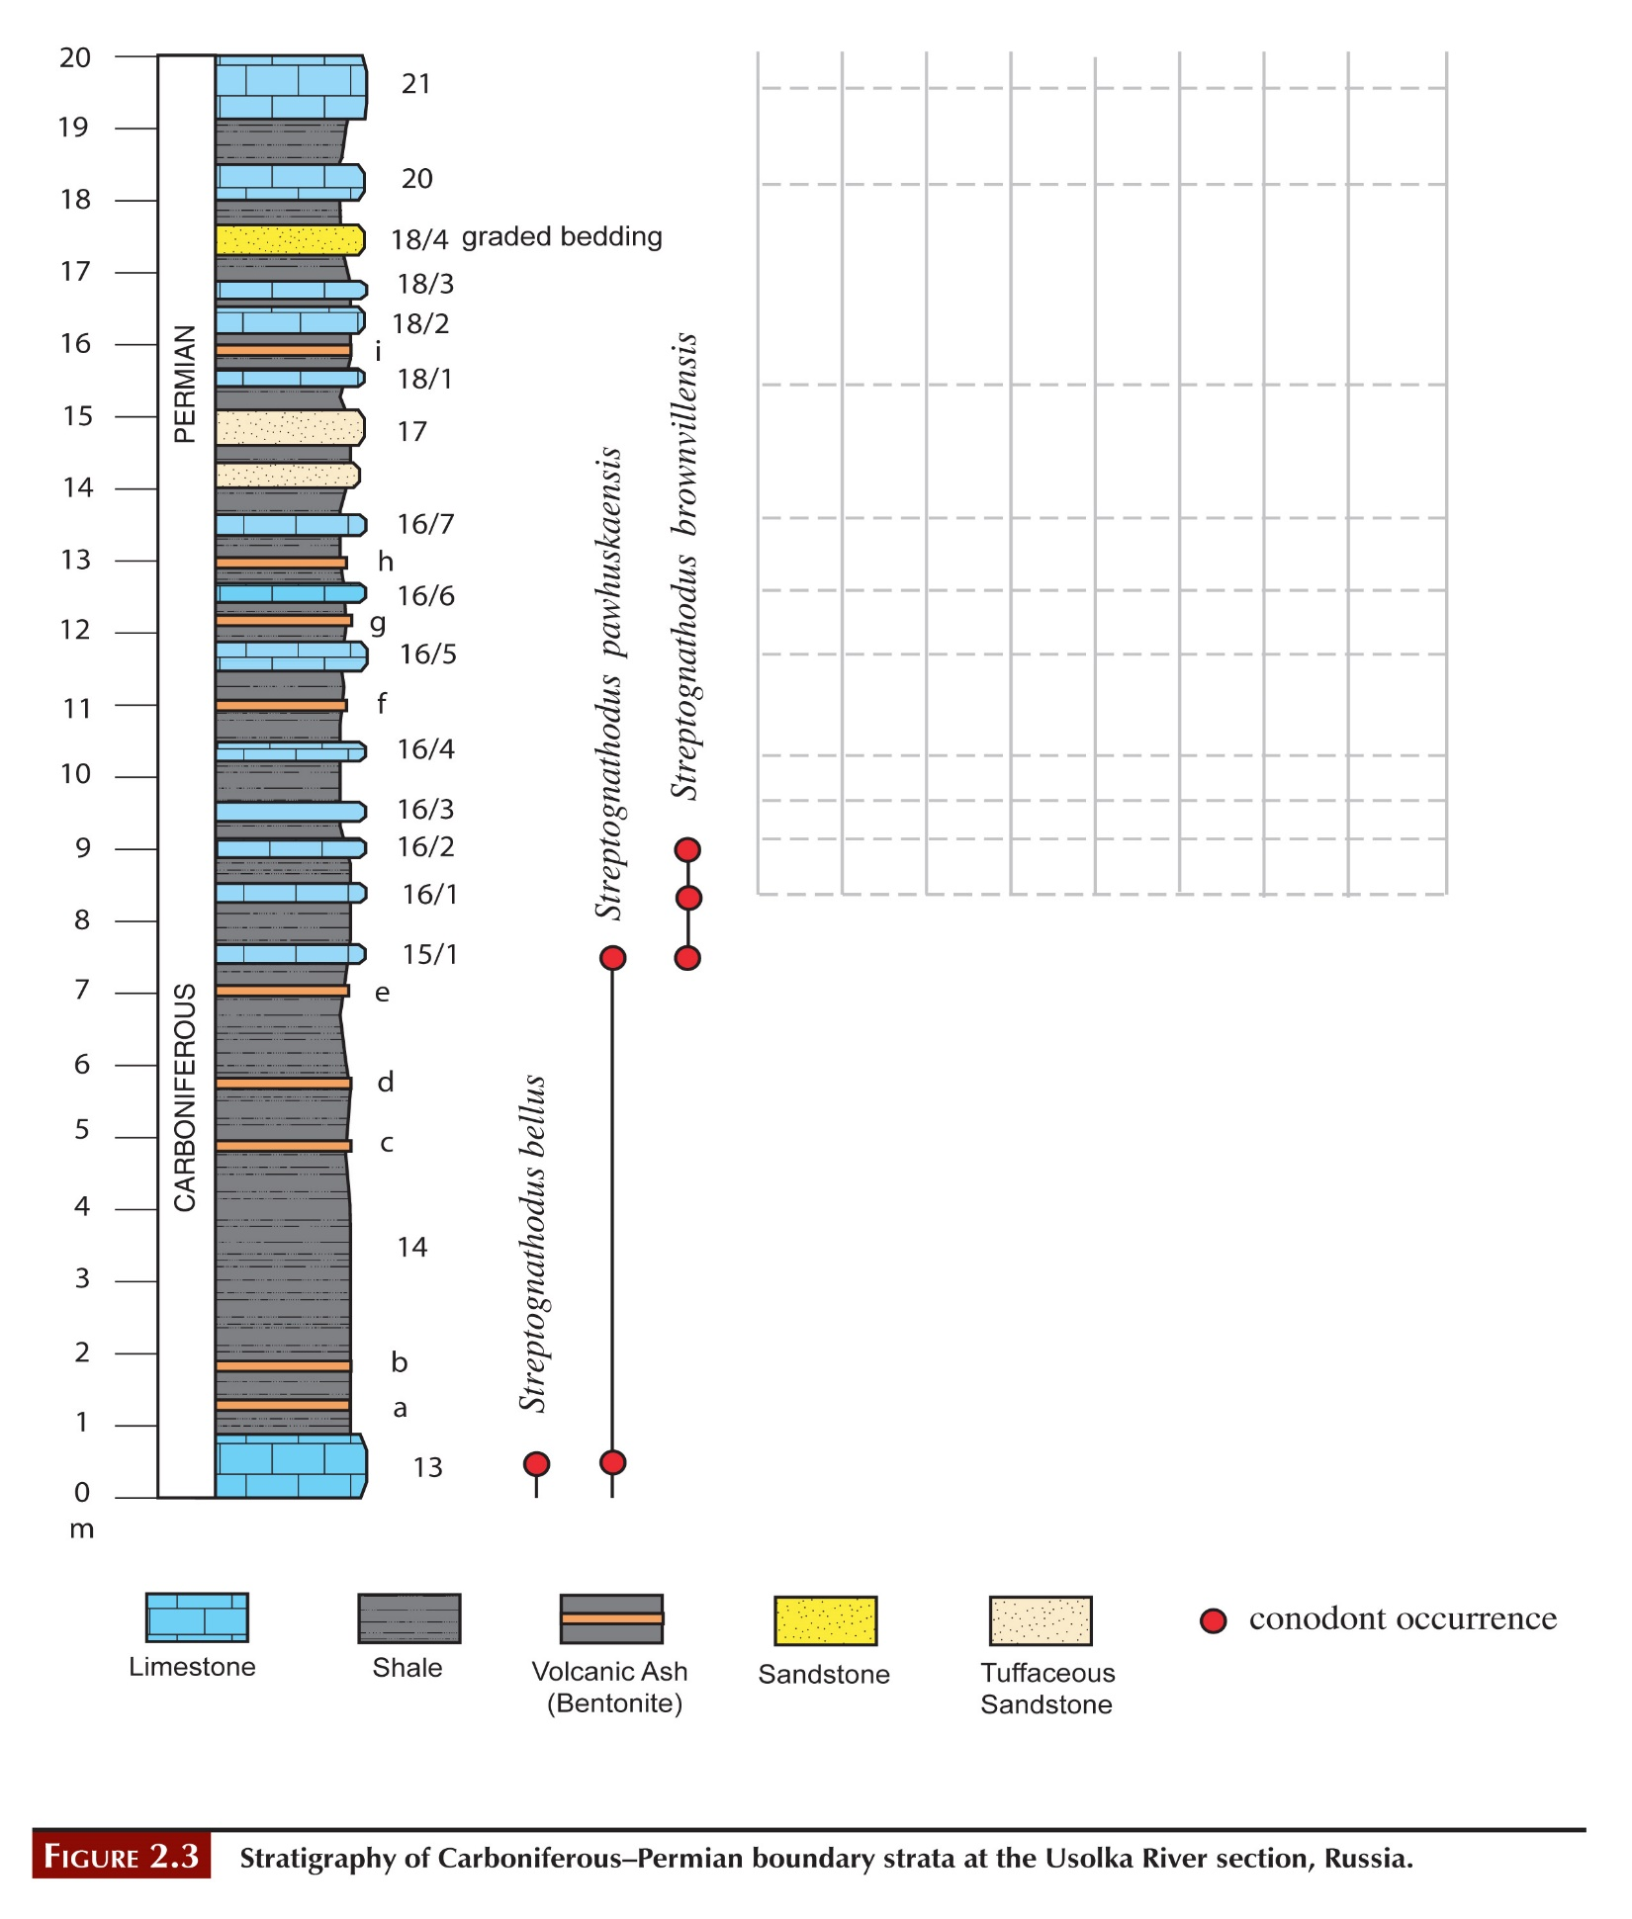

**2. Follow the directions on page 22 to complete the table below.**

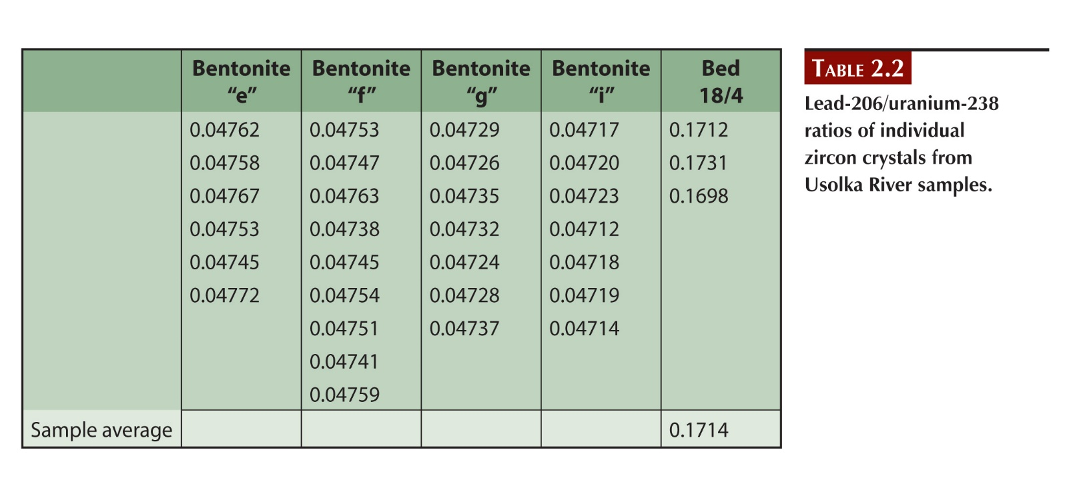

**3.**

**4.**

# **Post lab reflection**

**What concepts were most difficult in today’s lab activities?**

**What concepts were easiest to grasp?**

**What questions did today’s activities make you think of? What do you want to learn more about?**